Wishing Well [Variables, Branches]
Create a wishing well that has a chance to grant a player their wish that they choose when throwing a coin inside.

Start by creating a wishing well map event on the map you want the player to be able to wish. Then create as many custom choices as you want that they can get as chance when they wish. Follow the flow chart to create the Wishing Well event

Create: Map Event
 | Name | Wishing Well
 | Priority | Same As Player
 | Trigger | Action Button

Create: Memory
Variables | Death

Create: Memory
Variables | Chance

You will also need two variables those being Death and Chance, you can add more or change them depending on what you want different outcomes to be, they will both be set to a random number between 1-100.

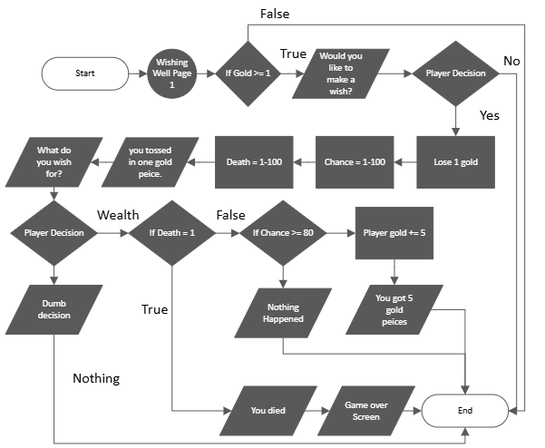

You can alter the chances and choices as much as you want. If you wish to create more choices for the play then you will simply copy the wealthy option and change the text and what the player gets from the other options to wish for. You can also change the text the play sees like you did in the Well assignment you have done before.

